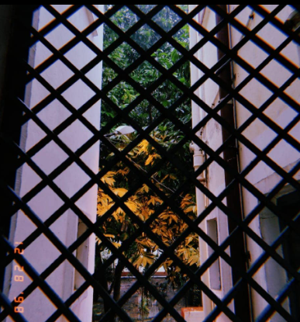
We all find something,
We all find someone,
We all find a story,
We all do burn once,

The ashes find some soil,
The ashes then become dirt,
the ashes don't remain just ashes,
from the soil does new life spurt,

we all find serenity,
we all then feel guilty
through the poems of those,
those who got hurt,

Those who bled in silence,
Those who were shut,
those finding new strength,
to burn or be burnt, as the world turns,

From ashes to ashes,
from dust, to dust,
we all are writing stories,
in which someone,
will find comfort,

So what soil will it be?
who will be the one,
reading you?
black, yellow, fertile or just red,
what soil will that seedling choose?

victims of one another,
victims of our shoes,
nobody is alone ,
nobody, is alone,
it scares me,
it gives me hope,
what path,
will nobody choose?

